- Consider the set of 6 documents (5 for training and 1 for testing).
docID |  | words in document | in class = cricket ?
1 |  | sachin dravid sachin | Yes
2 |  | dravid federer schools | No
3 |  | sachin sachin neville | Yes
4 |  | sachin drive | Yes
5 |  | saina sushil sachin | No
6 (test set) |  | sachin dravid neville federer | ?
Using the TF-IDF weight formula wt,d = (1+ log10tft,d)log10(N/dft), where N is the no. of documents in the collection, determine whether the Rocchio classification will assign document 6 to sports? Why?
- We wish to build an SVM classifier that categorizes a point into Class A or B based on 3 data points: (1, 1) {Class A), {2, O) (Class A) and (2, 3) (Class B).
(a) Find the optimal separating hyperplane w.
(b) Find the margin p.
(c) Plot the points on a small graph and depict the separator geometrically. Mark points, lines and distances clearly.

- Below is a training example where s_{T} and s_{B} represents whether the query word exits in title and body respectively. Assign weights to s_{T} and s_{B} to calculate the score of document-query pair such that the error is minimized. Error is defined as : ϵ(g,Ф_{j} ) = (r (d_{j} , q_{j} ) − score(d_{j} , q_{j} ))²
Consider r(d_{j} , q_{j}) as 1 for Relevant and 0 for Nonrelevant.
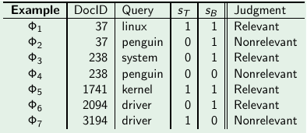

- Show that Rocchio classification can assign a label to a document that is different from its training set label.

